**Docker Linking**

1. Run a container in detached mode with name "db" from image "training/postgres"  
   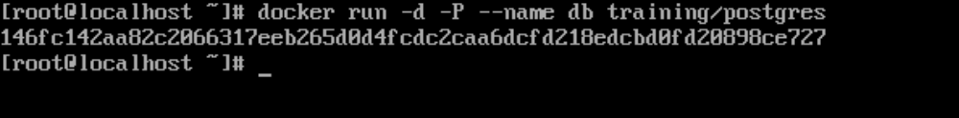  
   
2. Run another container in detached mode with name "web" from image "training/webapp", link container "db" with alias "mydb" to this container and finally pass an inline command "python app.py" while running container.  
   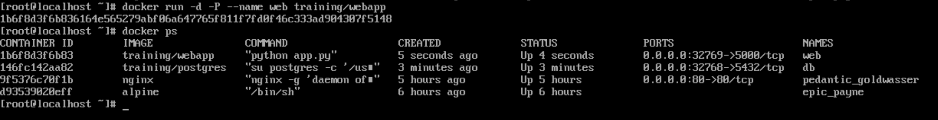  
   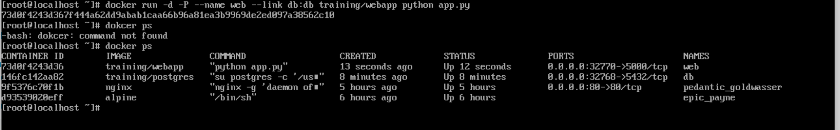
3. Take a bash terminal in "web" container.  
   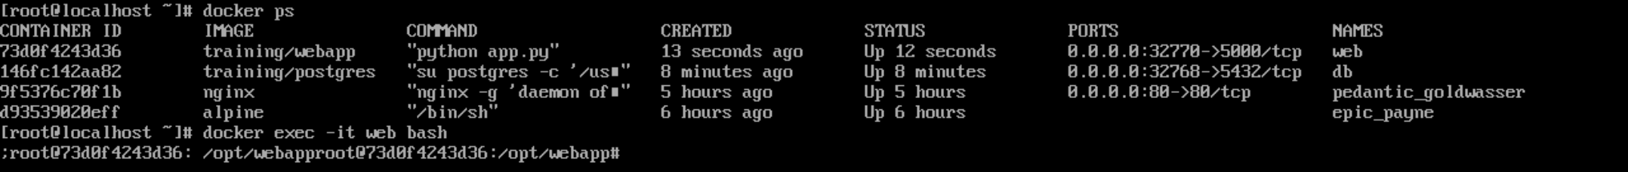
4. Test container linking by doing a ping to "mydb"  
   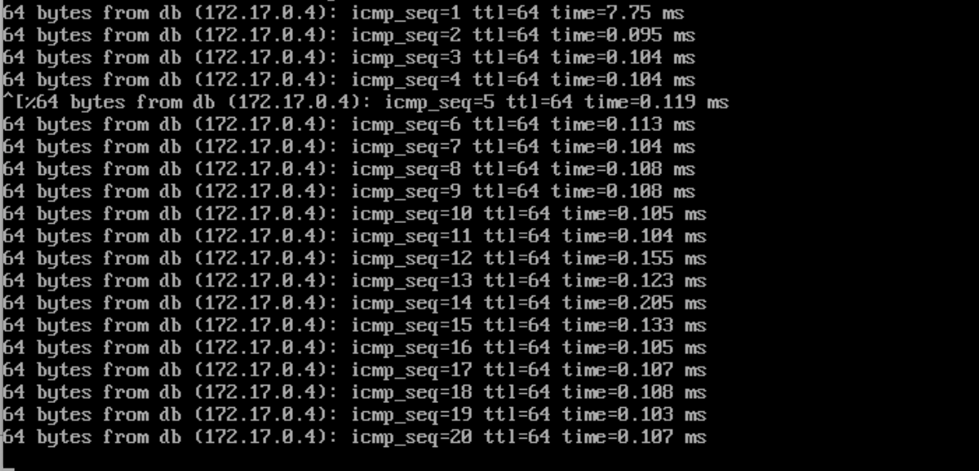  
     
   **Assignment 1**
5. Create a file named index.js with below content.  
   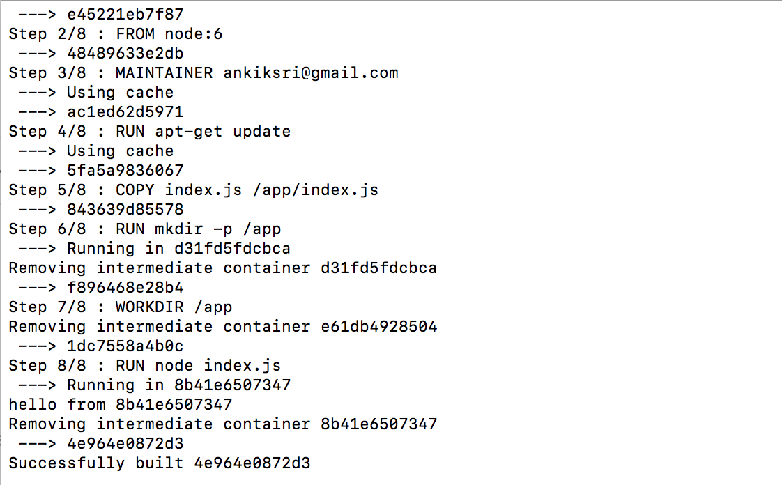  
     
     
   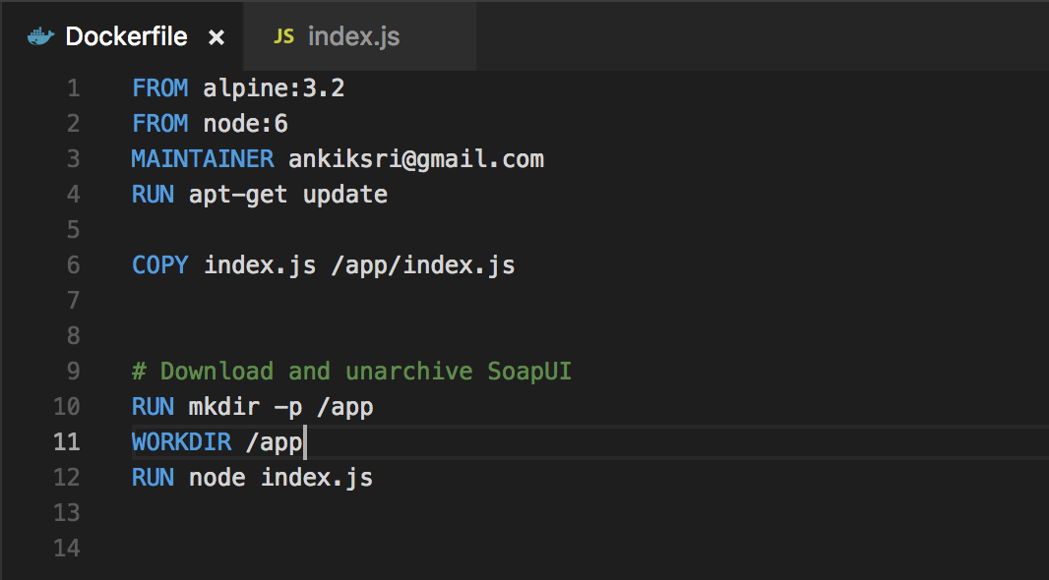  
   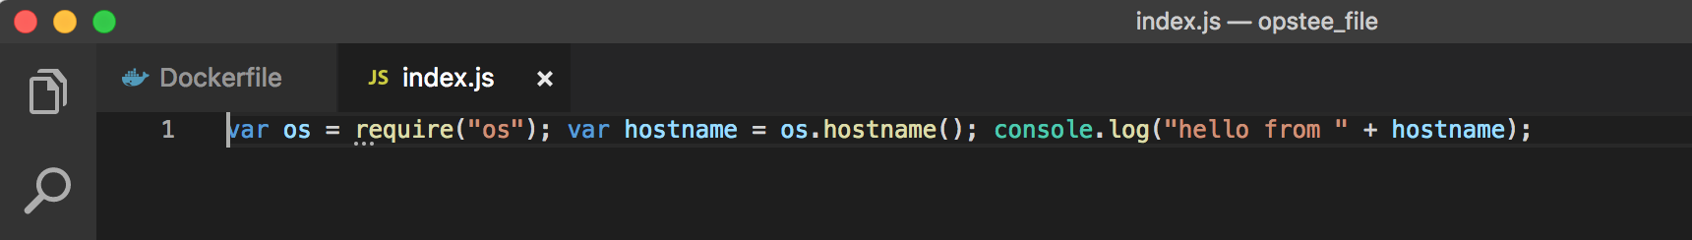

**Assignment 2**